11/19/2021

COMP1205

Assignment 1

Name: Tarika Birch

Student ID: 400013038

Lecturer: Mechelle Gittens

| **Test Scenario** | **Test Case** | **Pre-Conditions** | **Test Step** | **Test Data** | **Expected Result** | **Actual Result** | **Pass/Fail** |
| --- | --- | --- | --- | --- | --- | --- | --- |
| Check Game Setup Information  [1] | Check entering of valid name and skill level | N/A | 1. Launch Application 2. Enter name 3. Enter skill level | Name: Bob  Level: Rookie | Game board will be generated and displayed with 10 spaces empty and user will be given 1 hint | Game board is generated and displayed with 10 spaces empty and user is given 1 hint | Pass |
| Check Requesting a Hint  [2] | Check entering a valid hint request | N/A | 1. Enter hint request | Hint Request: yes | Game board will be printed with one additional slot filled in and user will be asked if they would like a hint again | Game board is printed with one additional slot filled in and user will be asked if they would like a hint again | Pass |
| Check Requesting a Hint  [3] | Check entering a valid hint request | N/A | 1. Enter hint request | Hint Request: no | User will be asked what number they would like to enter and where they would like to put it | User is asked what number they would like to enter and where they would like to put it | Pass |
| Playing the Game  [4] | Check entering a valid and correct number and location | N/A | 1. Do not request hint 2. Enter number to be placed 3. Enter row location 4. Enter column location | Number: 3  Row: 6  Col: 1 | Number will be placed in the location with the coordinates (row, col),  board will be printed with the new number placed and the user will be asked if they would like a hint or to quit | Number is placed in the location with the coordinates (row, col),  board is printed with the new number placed and the user will be asked if they would like a hint or to quit | Pass |
| Playing the Game  [5] | Check entering a valid and correct number and location | N/A | 1. Do not request hint 2. Enter number to be placed 3. Enter row location 4. Enter column location | Number: 5  Row: 4  Col: 1 | Number will be placed in the location with the coordinates (row, col),  board will be printed with the new number placed and the user will be asked if they would like a hint or to quit | Number is placed in the location with the coordinates (row, col),  board is printed with the new number placed and the user will be asked if they would like a hint or to quit | Pass |
| Playing the Game  [6] | Check entering a valid and correct number and location | N/A | 1. Do not request hint 2. Enter number to be placed 3. Enter row location 4. Enter column location | Number: 6  Row: 3  Col: 3 | Number will be placed in the location with the coordinates (row, col),  board will be printed with the new number placed and the user will be asked if they would like a hint or to quit | Number is placed in the location with the coordinates (row, col),  board is printed with the new number placed and the user will be asked if they would like a hint or to quit | Pass |
| Playing the Game  [7] | Check entering a valid and correct number and location | N/A | 1. Do not request hint 2. Enter number to be placed 3. Enter row location 4. Enter column location | Number: 4  Row: 4  Col: 6 | Number will be placed in the location with the coordinates (row, col),  board will be printed with the new number placed and the user will be asked if they would like a hint or to quit | Number is placed in the location with the coordinates (row, col),  board is printed with the new number placed and the user will be asked if they would like a hint or to quit | Pass |
| Playing the Game  [8] | Check entering a valid and correct number and location | N/A | 1. Do not request hint 2. Enter number to be placed 3. Enter row location 4. Enter column location | Number: 6  Row: 6  Col: 2 | Number will be placed in the location with the coordinates (row, col),  board will be printed with the new number placed and the user will be asked if they would like a hint or to quit | Number is placed in the location with the coordinates (row, col),  board is printed with the new number placed and the user will be asked if they would like a hint or to quit | Pass |
| Playing the Game  [9] | Check entering a valid and correct number and location | N/A | 1. Do not request hint 2. Enter number to be placed 3. Enter row location 4. Enter column location | Number: 5  Row: 6  Col: 5 | Number will be placed in the location with the coordinates (row, col),  board will be printed with the new number placed and the user will be asked if they would like a hint or to quit | Number is placed in the location with the coordinates (row, col),  board is printed with the new number placed and the user will be asked if they would like a hint or to quit | Pass |
| Playing the Game  [10] | Check entering a valid and correct number and location | N/A | 1. Do not request hint 2. Enter number to be placed 3. Enter row location 4. Enter column location | Number: 1  Row: 5  Col: 3 | Number will be placed in the location with the coordinates (row, col),  board will be printed with the new number placed and the user will be asked if they would like a hint or to quit | Number is placed in the location with the coordinates (row, col),  board is printed with the new number placed and the user will be asked if they would like a hint or to quit | Pass |
| Playing the Game  [11] | Check entering a valid and correct number and location | N/A | 1. Do not request hint 2. Enter number to be placed 3. Enter row location 4. Enter column location | Number: 1  Row: 4  Col: 4 | Number will be placed in the location with the coordinates (row, col),  board will be printed with the new number placed and the user will be asked if they would like a hint or to quit | Number is placed in the location with the coordinates (row, col),  board is printed with the new number placed and the user will be asked if they would like a hint or to quit | Pass |
| Playing the Game  [12] | Check entering a valid but incorrect number into an invalid location | N/A | 1. Do not request hint 2. Enter number to be placed 3. Enter row location 4. Enter column location | Number: 5  Row: 3  Col: 3 | Invalid Location message will be displayed, user will be asked to try again | Invalid Location Message is displayed, user is asked to try again | Pass |
| Playing the Game  [13] | Check entering a valid but incorrect number into a valid location | N/A | 1. Do not request hint 2. Enter number to be placed 3. Enter row location 4. Enter column location | Number: 2  Row: 5  Col: 4 | Incorrect message will be displayed, user will be asked to try again | Incorrect message will be displayed, user will be asked to try again | Pass |
| Completing the Game  [14] | Check completing the game by filling all the slots | N/A | 1. Do not request hint 2. Enter number to be placed 3. Enter row location 4. Enter column location | Number: 4  Row: 5  Col: 4 | Number will be placed. Completed game board will be displayed to the screen with a congratulatory message and the user’s score. User will be asked if they would like to play again | Number is placed. Completed game board is displayed to the screen with a congratulatory message and the user’s score. User is asked if they would like to play again | Pass |
| Playing Again  [15] | Check Starting a New Game | N/A | 1. Complete Previous game 2. Request a new game | New Game?: yes | Game Instructions will be displayed to the screen. User will be asked to enter their name and skill level. | Game instructions are printed to the screen. User is asked to enter their name and skill level | Pass |
| Check Game Setup Information  [16] | Check entering of valid name and skill level | N/A | 1. Request a new game 2. Enter name and skill level | Name: Bob  Level: Tuff Gong | Game board will be generated and displayed with 15 spaces empty and user will be given 2 hints | Game board is generated and displayed with 15 spaces empty and user is given 2 hints | Pass |
| Check Requesting a Hint  [17] | Check entering a valid hint request | N/A | 1. Request a new game  2. Enter name and skill level  3. Enter hint request | Hint Request: yes | Game board will be printed with one additional slot filled in and user will be asked if they would like a hint again | Game board is printed with one additional slot filled in and user will be asked if they would like a hint again | Pass |
| Check Requesting a Hint  [18] | Check entering a valid hint request | N/A | 1. Enter hint request | Hint Request: yes | Game board will be printed with one additional slot filled in and user will be asked if they would like a hint again | Game board is printed with one additional slot filled in and user will be asked if they would like a hint again | Pass |
| Check Requesting a Hint  [19] | Check entering a valid hint request when there are no hints left | N/A | 1. Enter hint request | Hint Request: yes | Game Over message will be printed with the completed board and a total score of 0 .The user will be asked if they would like to play again | Game Over message is printed with the completed board and a total score of 0 .The user is asked if they would like to play again | Pass |
| Playing Again  [20] | Check Starting a New Game | N/A | 1. Complete Previous game 2. Request a new game | New Game?: yes | Game Instructions will be displayed to the screen. User will be asked to enter their name and skill level. | Game instructions are printed to the screen. User is asked to enter their name and skill level | Pass |
| Check Game Setup Information  [21] | Check entering of valid name and skill level | N/A | 1. Request a new game 2. Enter name and skill level | Name: Bob  Level: hard seed | Game board will be generated and displayed with 20 spaces empty and user will be given 3 hints | Game board is generated and displayed with 20 spaces empty and user is given 3 hints | Pass |
| Check Requesting a Hint  [22] | Check entering a valid hint request | N/A | 1. Request a new game 2. Enter name and skill level 3. Enter hint request | Hint Request: yes | Game board will be printed with one additional slot filled in and user will be asked if they would like a hint again | Game board is printed with one additional slot filled in and user will be asked if they would like a hint again | Pass |
| Check Requesting a Hint  [23] | Check entering a valid hint request | N/A | 1. Enter hint request | Hint Request: yes | Game board will be printed with one additional slot filled in and user will be asked if they would like a hint again | Game board is printed with one additional slot filled in and user will be asked if they would like a hint again | Pass |
| Quitting the Game  [24] | Check entering a request to quit the game | N/A | 1. Enter request to quit | Hint Request: quit | Game Over message will be printed with the completed board and a total score of 0 .The user will be asked if they would like to play again | Game Over message is printed with the completed board and a total score of 0 .The user is asked if they would like to play again | Pass |
| Terminating the Program  [25] | Check entering the option to not play again | N/A | 1. Do not request to play again | Play Again?: no | A messaged thanking the user for playing will be printed and the program will be terminated | A messaged thanking the user for playing is printed and the program is terminated | Pass |

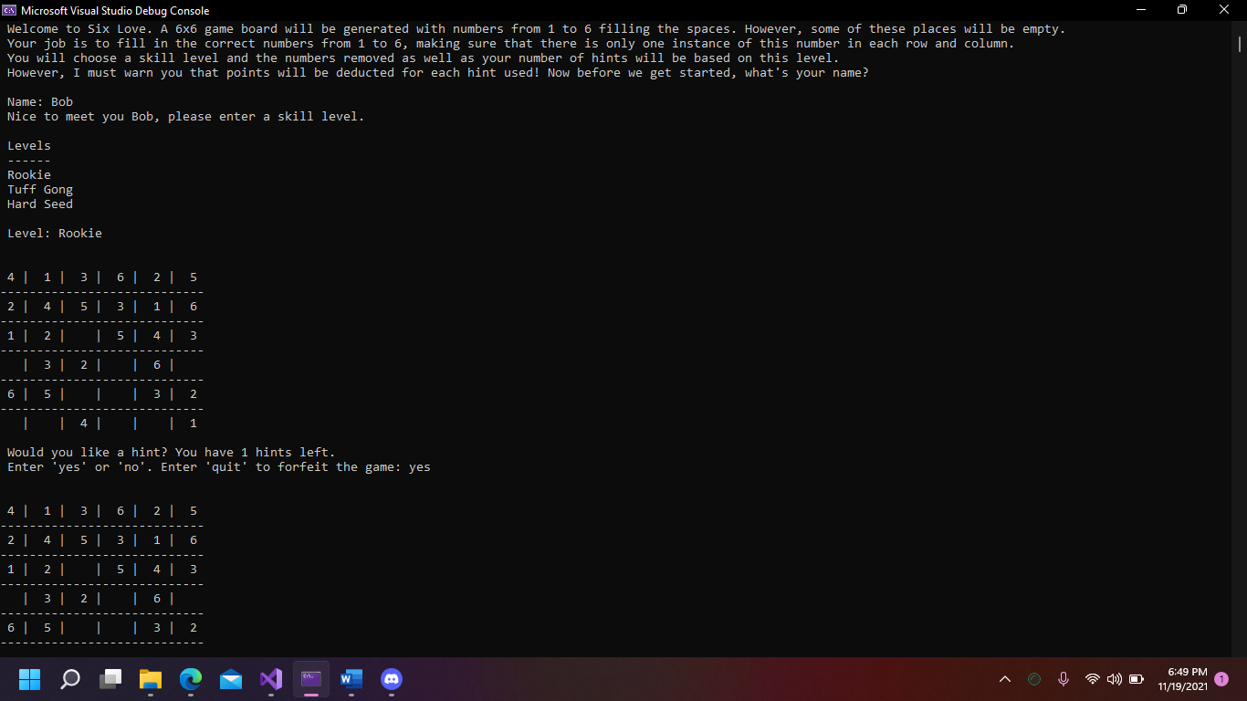

**Figure 1. Test Scenarios 1 - 2**

**Figure 2. Test Scenarios 3 - 4**

**Figure 3. Test Scenarios 5 - 6**

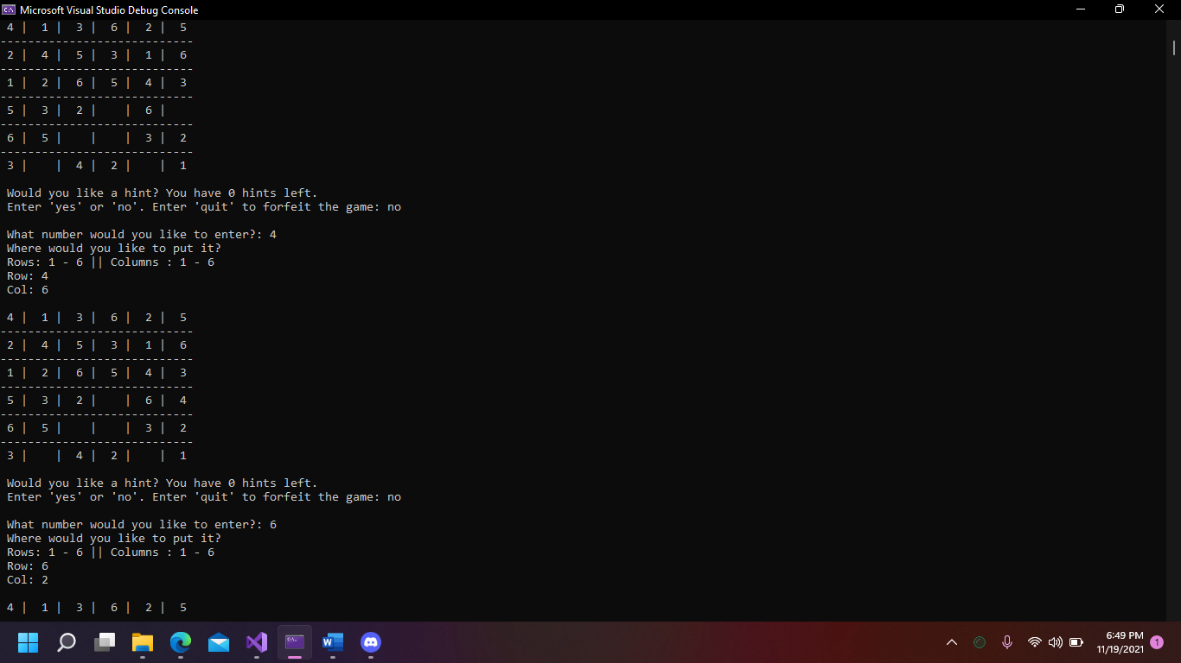

**Figure 4. Test Scenarios 7 - 8**

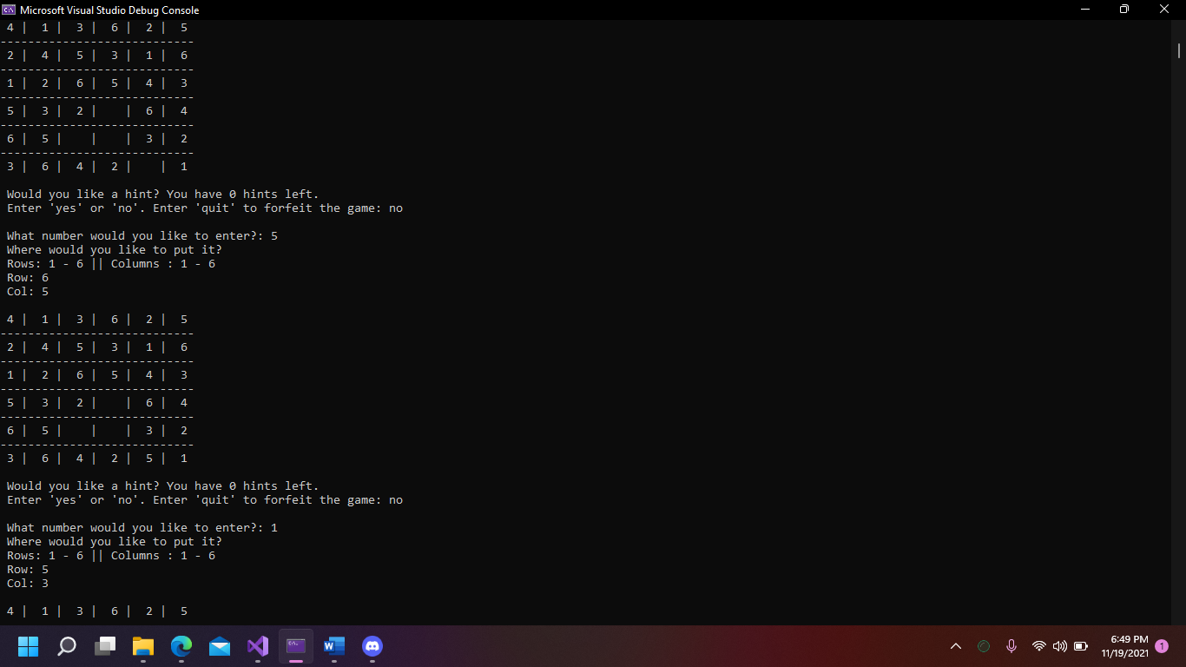

**Figure 5. Test Scenarios 9 - 10**

**Figure 6. Test Scenarios 11 - 12**

**Figure 7. Test Scenarios 13 - 15**

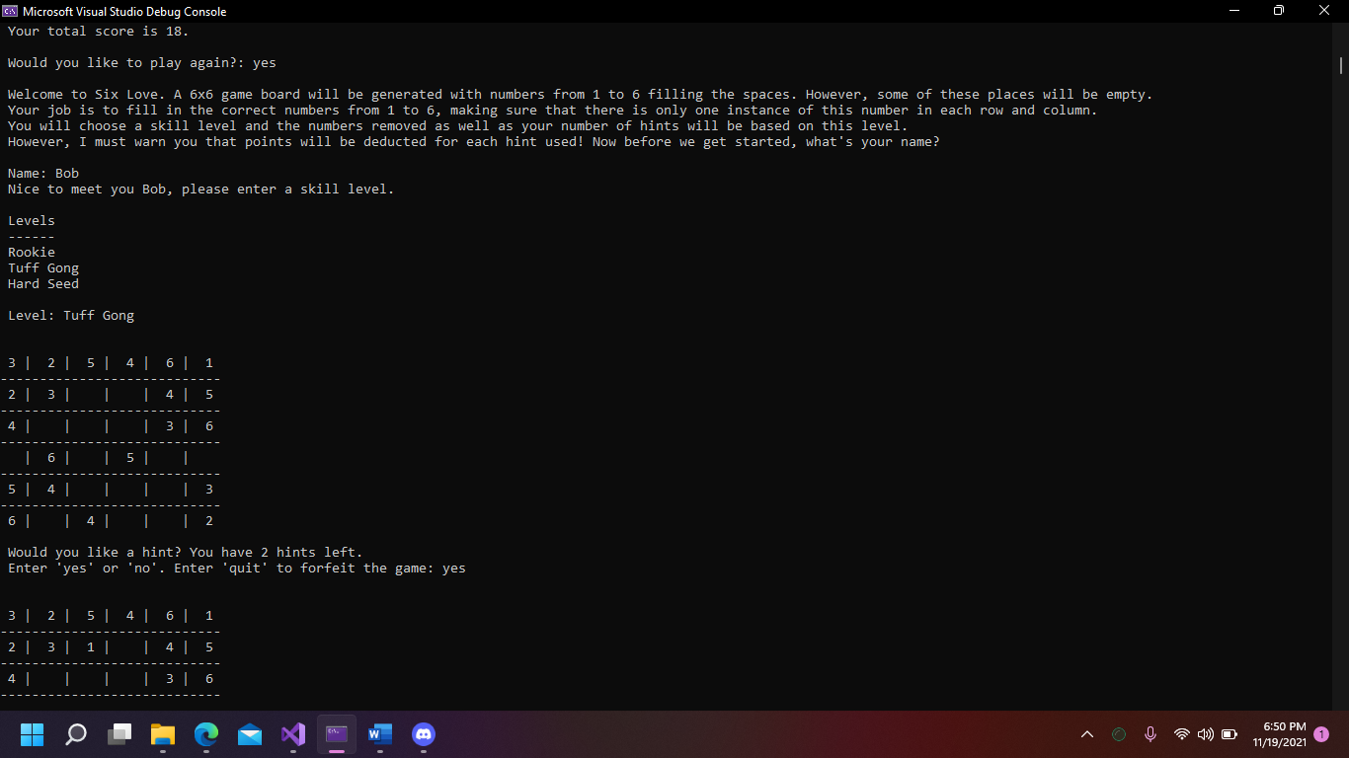

**Figure 8. Test Scenarios 16 - 17**

**Figure 9. Test Scenarios 18 - 19**

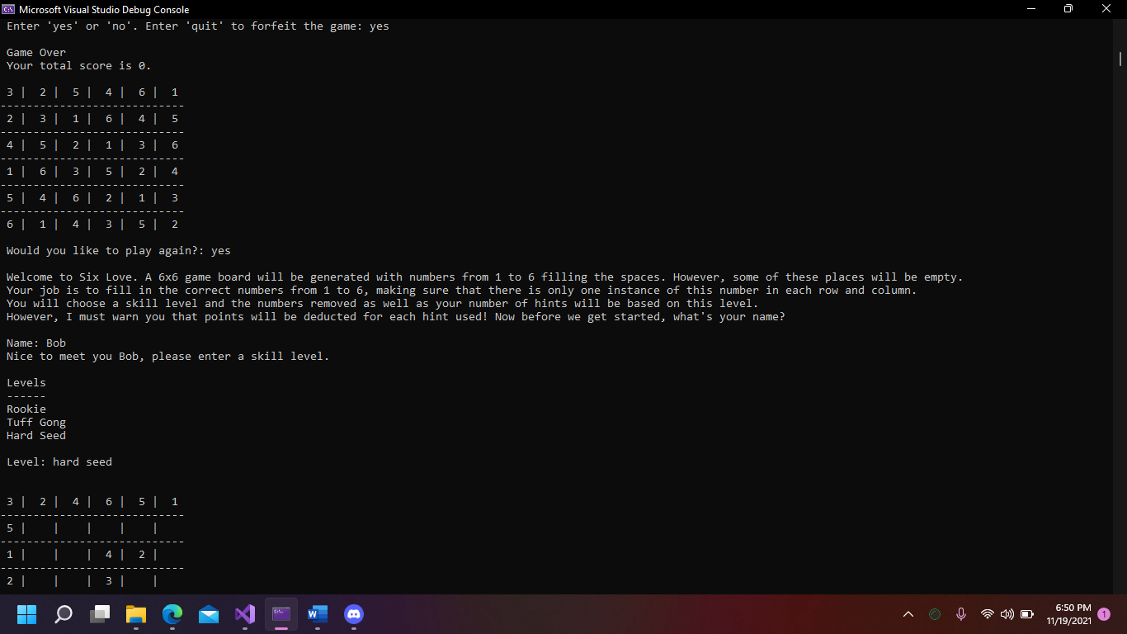

**Figure 10. Test Scenarios 20 - 21**

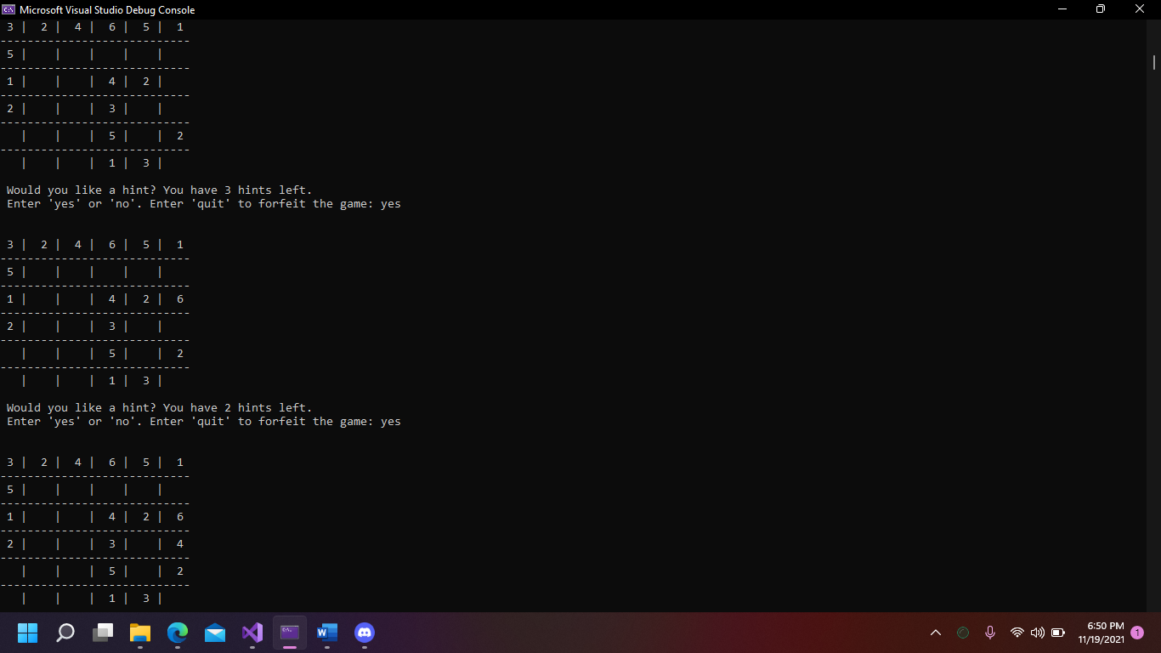

**Figure 11. Test Scenarios 22 - 23**

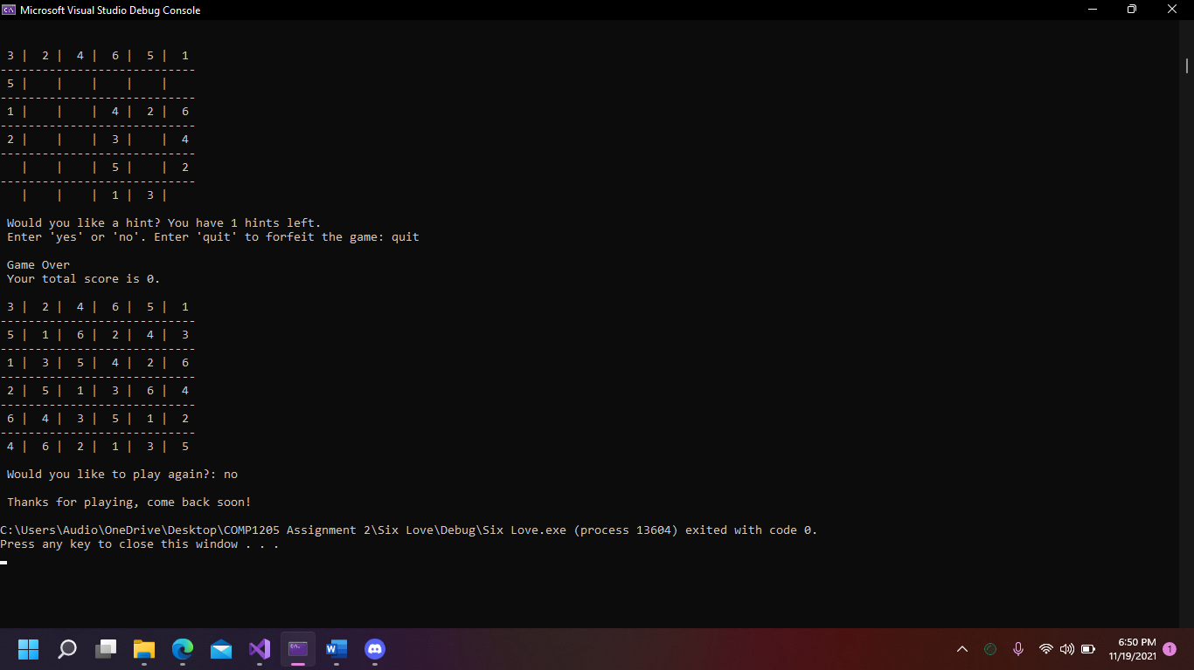

**Figure 12. Test Scenarios 24 - 25**

| **Test Scenario** | **Test Case** | **Pre-Conditions** | **Test Step** | **Test Data** | **Expected Result** | **Actual Result** | **Pass/Fail** |
| --- | --- | --- | --- | --- | --- | --- | --- |
| Check Game Setup Information  [1] | Check entering of valid name and invalid skill level | N/A | 1. Launch Application 2. Enter name 3. Enter skill level | Name: Tarika  Level: Rook | Invalid Level message will be printed and user will be asked to enter a skill level again | Invalid Level message is printed and user is asked to enter a skill level again | Pass |
| Check Game Setup Information  [2] | Check entering of valid name and valid skill level | N/A | 1. Enter valid skill level | Name: Tarika  Level: Rook | Game board will be generated and displayed with 10 spaces empty and user will be given 1 hint | Game board is generated and displayed with 10 spaces empty and user is given 1 hint | Pass |
| Check Requesting a Hint  [3] | Check entering a valid hint request | N/A | 1. Enter hint request | Hint Request: yes | Game board will be printed with one additional slot filled in and user will be asked if they would like a hint again | Game board is printed with one additional slot filled in and user will be asked if they would like a hint again | Pass |
| Check Requesting a Hint  [4] | Check entering a valid hint request | N/A | 1. Enter hint request | Hint Request: no | User will be asked what number they would like to enter and where they would like to put it | User is asked what number they would like to enter and where they would like to put it | Pass |
| Playing the Game  [5] | Check entering a valid and correct number and location | N/A | 1. Do not request hint 2. Enter number to be placed 3. Enter row location 4. Enter column location | Number: 4  Row: 4  Col: 6 | Number will be placed in the location with the coordinates (row, col),  board will be printed with the new number placed and the user will be asked if they would like a hint or to quit | Number is placed in the location with the coordinates (row, col),  board is printed with the new number placed and the user will be asked if they would like a hint or to quit | Pass |
| Playing the Game  [6] | Check entering a valid but incorrect number and a valid location | N/A | 1. Do not request hint 2. Enter number to be placed 3. Enter row location 4. Enter column location | Number: 1  Row: 3  Col: 2 | Incorrect message will be displayed, user will be asked to try again | Incorrect message will be displayed, user will be asked to try again | Pass |
| Playing the Game  [7] | Check entering a valid and correct number and location | N/A | 1. Enter number to be placed 2. Enter row location 3. Enter column location | Number: 1  Row: 6  Col: 2 | Number will be placed in the location with the coordinates (row, col),  board will be printed with the new number placed and the user will be asked if they would like a hint or to quit | Number is placed in the location with the coordinates (row, col),  board is printed with the new number placed and the user will be asked if they would like a hint or to quit | Pass |
| Playing the Game  [8] | Check entering a valid and correct number and location | N/A | 1. Do not request hint 2. Enter number to be placed 3. Enter row location 4. Enter column location | Number: 5  Row: 3  Col: 2 | Number will be placed in the location with the coordinates (row, col),  board will be printed with the new number placed and the user will be asked if they would like a hint or to quit | Number is placed in the location with the coordinates (row, col),  board is printed with the new number placed and the user will be asked if they would like a hint or to quit | Pass |
| Playing the Game  [9] | Check entering a valid and correct number and location | N/A | 1. Do not request hint 2. Enter number to be placed 3. Enter row location 4. Enter column location | Number: 2  Row: 3  Col: 3 | Number will be placed in the location with the coordinates (row, col),  board will be printed with the new number placed and the user will be asked if they would like a hint or to quit | Number is placed in the location with the coordinates (row, col),  board is printed with the new number placed and the user will be asked if they would like a hint or to quit | Pass |
| Playing the Game  [10] | Check entering a valid and correct number and location | N/A | 1. Do not request hint 2. Enter number to be placed 3. Enter row location 4. Enter column location | Number: 1  Row: 3  Col: 4 | Number will be placed in the location with the coordinates (row, col),  board will be printed with the new number placed and the user will be asked if they would like a hint or to quit | Number is placed in the location with the coordinates (row, col),  board is printed with the new number placed and the user will be asked if they would like a hint or to quit | Pass |
| Playing the Game  [11] | Check entering a valid and correct number and location | N/A | 1. Do not request hint 2. Enter number to be placed 3. Enter row location 4. Enter column location | Number: 2  Row: 4  Col: 5 | Number will be placed in the location with the coordinates (row, col),  board will be printed with the new number placed and the user will be asked if they would like a hint or to quit | Number is placed in the location with the coordinates (row, col),  board is printed with the new number placed and the user will be asked if they would like a hint or to quit | Pass |
| Playing the Game  [12] | Check entering a valid but incorrect number into an invalid location | N/A | 1. Do not request hint 2. Enter number to be placed 3. Enter row location 4. Enter column location | Number: 1  Row: 2  Col: 2 | Invalid Location message will be displayed, user will be asked to try again | Invalid Location Message is displayed, user is asked to try again | Pass |
| Playing the Game  [13] | Check entering a valid and correct number and location | N/A | 1. Do not request hint 2. Enter number to be placed 3. Enter row location 4. Enter column location | Number: 1  Row: 5  Col: 5 | Number will be placed in the location with the coordinates (row, col),  board will be printed with the new number placed and the user will be asked if they would like a hint or to quit | Number is placed in the location with the coordinates (row, col),  board is printed with the new number placed and the user will be asked if they would like a hint or to quit | Pass |
| Check Requesting a Hint  [14] | Check entering an invalid hint request | N/A | 1. Enter hint request | Hint Request: 5 | User will be asked to request a hint again | User is asked to request a hint again | Pass |
| Playing the Game  [15] | Check entering a valid and correct number and location | N/A | 1. Do not request hint 2. Enter number to be placed 3. Enter row location 4. Enter column location | Number: 5  Row: 6  Col: 5 | Number will be placed in the location with the coordinates (row, col),  board will be printed with the new number placed and the user will be asked if they would like a hint or to quit | Number is placed in the location with the coordinates (row, col),  board is printed with the new number placed and the user will be asked if they would like a hint or to quit | Pass |
| Completing the Game  [16] | Check completing the game by filling all the slots | N/A | 1. Do not request hint 2. Enter number to be placed 3. Enter row location 4. Enter column location | Number: 3  Row: 6  Col: 4 | Number will be placed. Completed game board will be displayed to the screen with a congratulatory message and the user’s score. User will be asked if they would like to play again | Number is placed. Completed game board is displayed to the screen with a congratulatory message and the user’s score. User is asked if they would like to play again | Pass |
| Playing Again  [17] | Check Starting a New Game | N/A | 1. Complete Previous game 2. Request a new game | New Game?: yes | Game Instructions will be displayed to the screen. User will be asked to enter their name and skill level. | Game instructions are printed to the screen. User is asked to enter their name and skill level | Pass |
| Check Game Setup Information  [18] | Check entering of valid name and skill level | N/A | 1. Request a new game 2. Enter name and skill level | Name: Bob  Level: tuff gong | Game board will be generated and displayed with 15 spaces empty and user will be given 2 hints | Game board is generated and displayed with 15 spaces empty and user is given 2 hints | Pass |
| Check Requesting a Hint  [19] | Check entering an invalid hint request | N/A | 1. Request a new game  2. Enter name and skill level  3. Enter hint request | Hint Request: y | User will be asked to request a hint again | User is asked to request a hint again | Pass |
| Check Requesting a Hint  [20] | Check entering a valid hint request | N/A | 1. Request a new game  2. Enter name and skill level  3. Enter hint request | Hint Request: yes | Game board will be printed with one additional slot filled in and user will be asked if they would like a hint again | Game board is printed with one additional slot filled in and user will be asked if they would like a hint again | Pass |
| Check Requesting a Hint  [21] | Check entering a valid hint request | N/A | 1. Enter hint request | Hint Request: yes | Game board will be printed with one additional slot filled in and user will be asked if they would like a hint again | Game board is printed with one additional slot filled in and user will be asked if they would like a hint again | Pass |
| Check Requesting a Hint  [22] | Check entering a valid hint request when there are no hints left | N/A | 1. Enter hint request | Hint Request: yes | Game Over message will be printed with the completed board and a total score of 0 .The user will be asked if they would like to play again | Game Over message is printed with the completed board and a total score of 0 .The user is asked if they would like to play again | Pass |
| Terminating the Program  [23] | Check entering an invalid request to play again | N/A | 1. Do not request to play again | Play Again?: n | A messaged thanking the user for playing will be printed and the program will be terminated | A messaged thanking the user for playing is printed and the program is terminated | Pass |

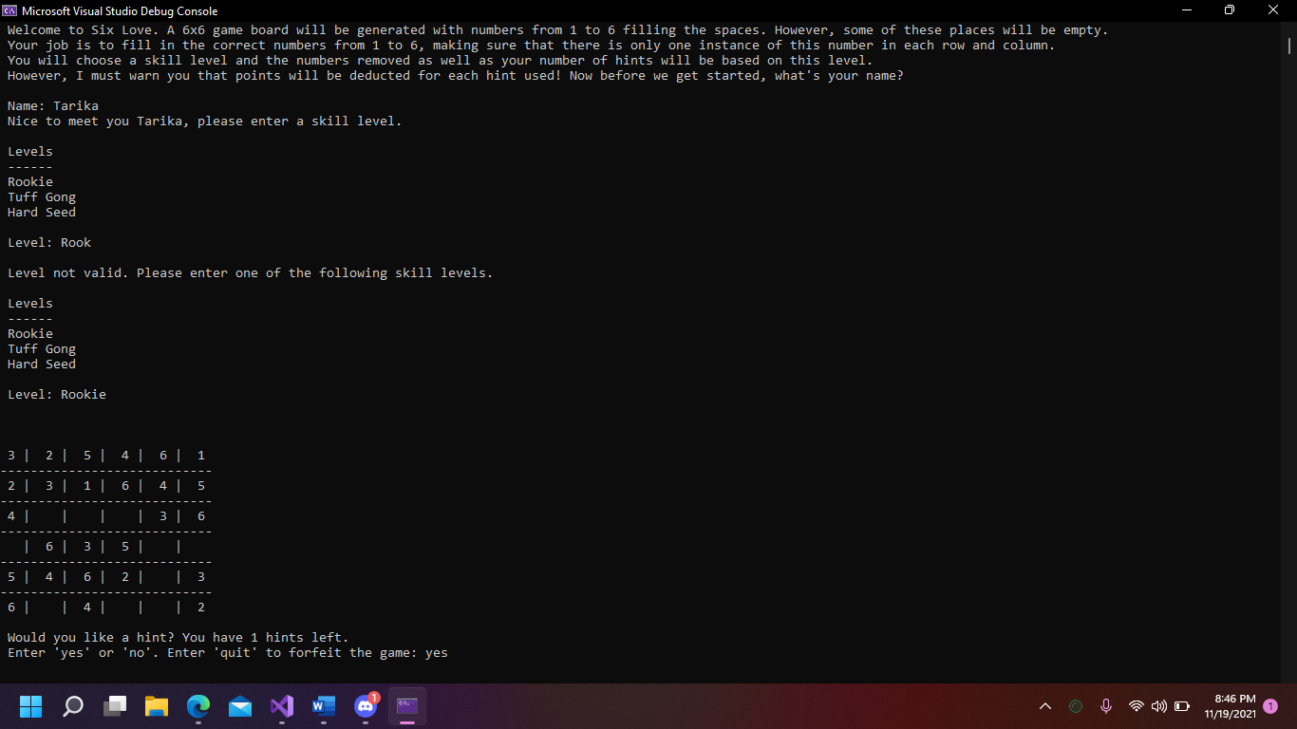

**Figure 13. Test Scenarios 1 - 3**

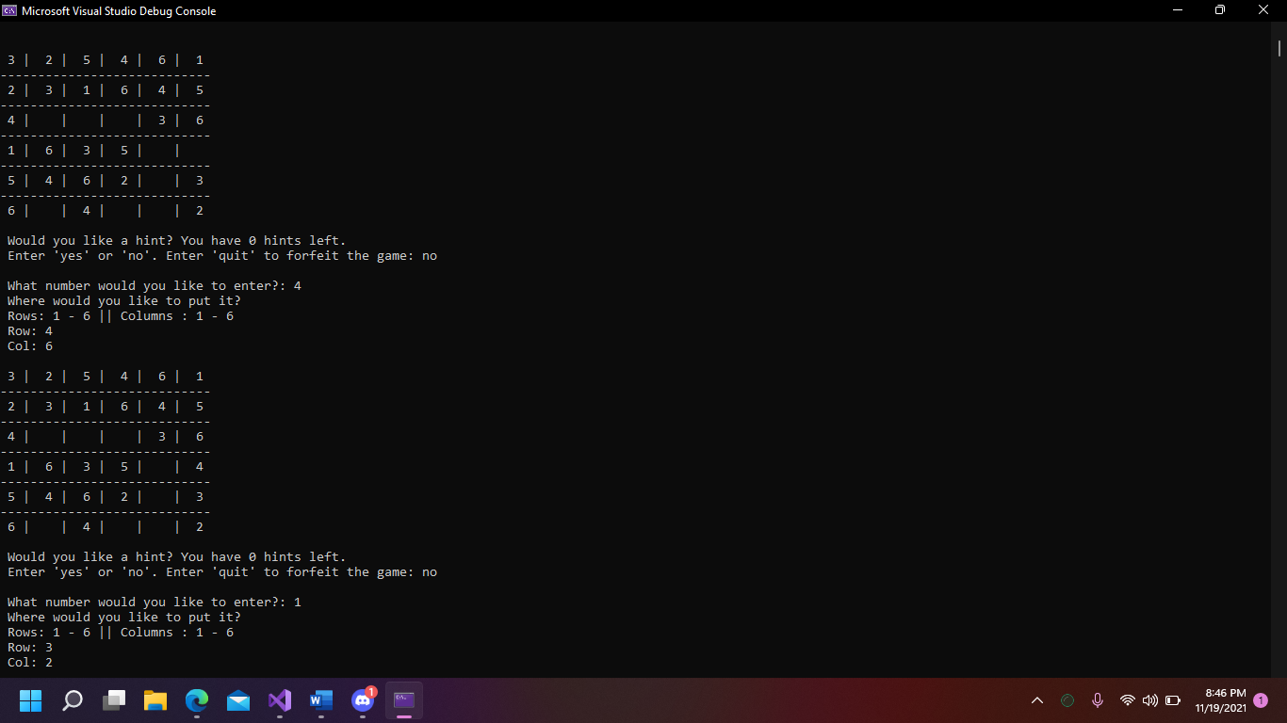

**Figure 14. Test Scenarios 3 - 5**

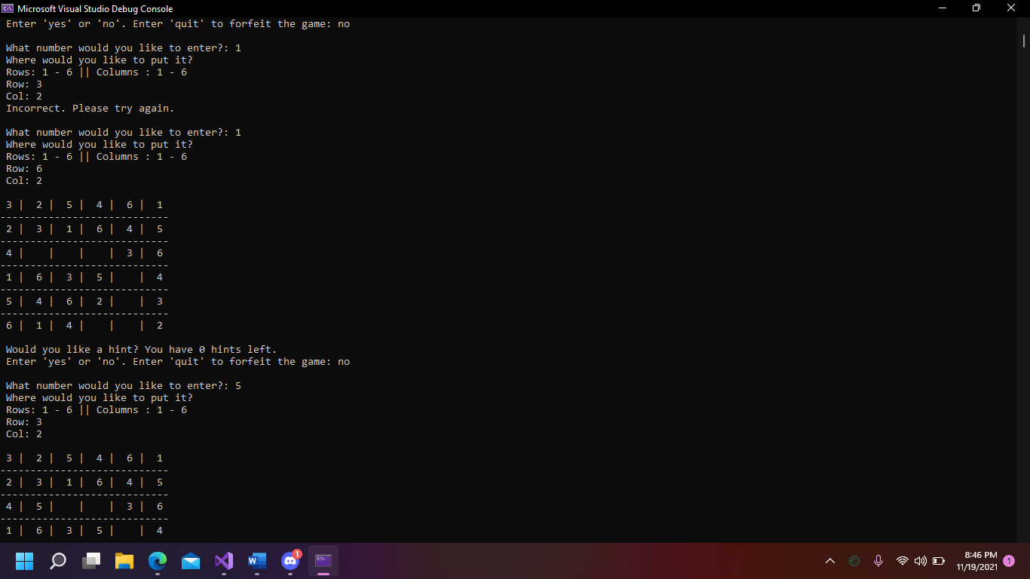

**Figure 15. Test Scenarios 6 - 8**

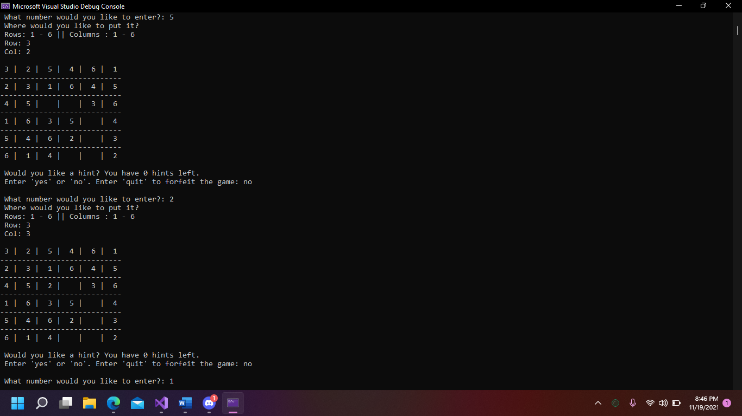

**Figure 16. Test Scenarios 8 - 9**

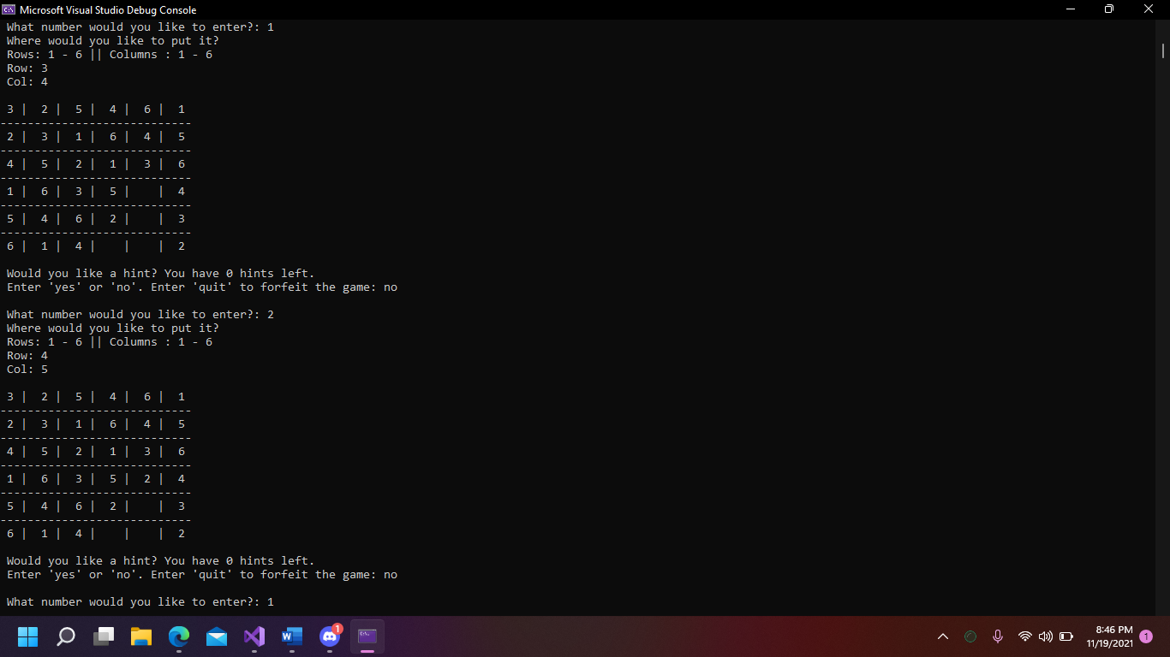

**Figure 17. Test Scenarios 10 - 11**

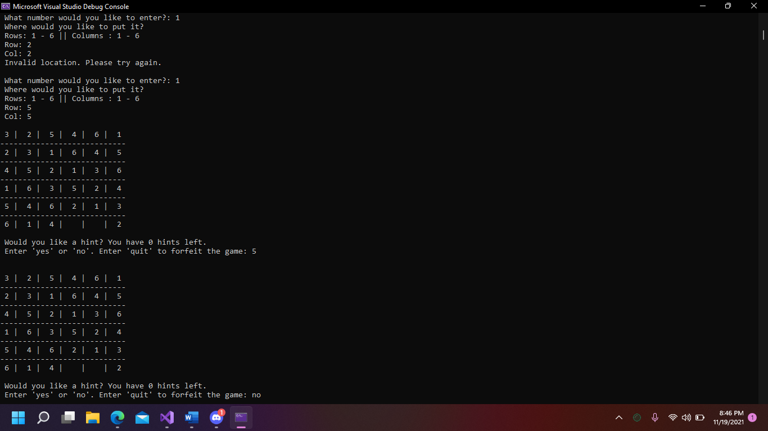

**Figure 18. Test Scenarios 12 - 14**

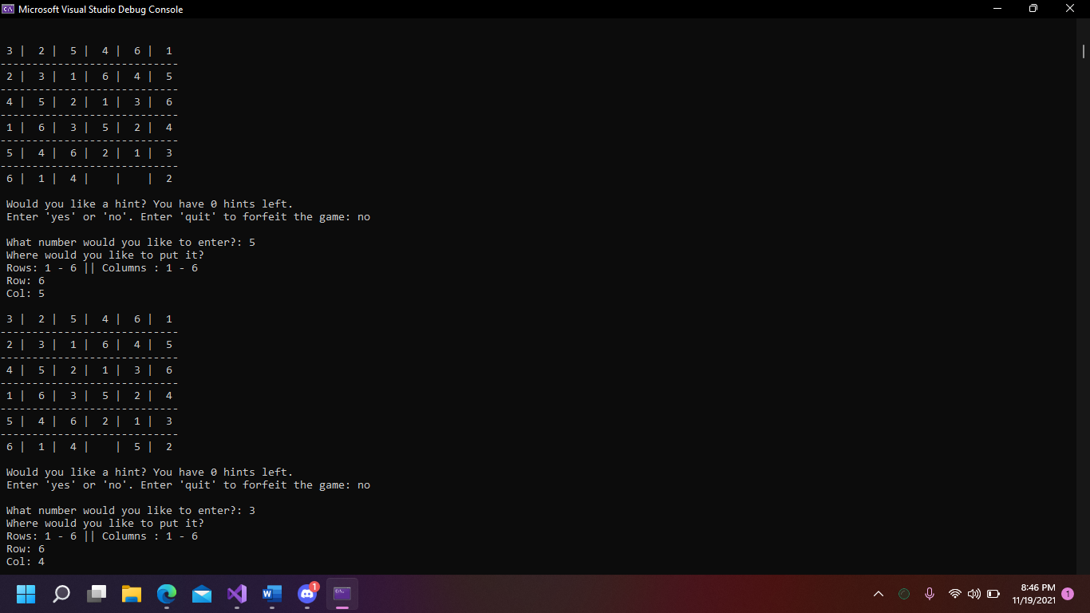

**Figure 19. Test Scenarios 15 - 16**

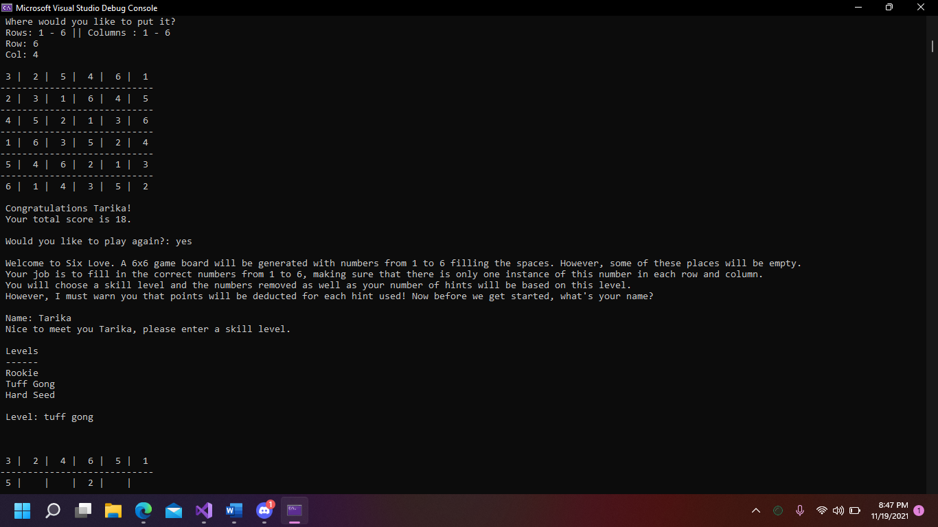

**Figure 20. Test Scenarios 16 - 18**

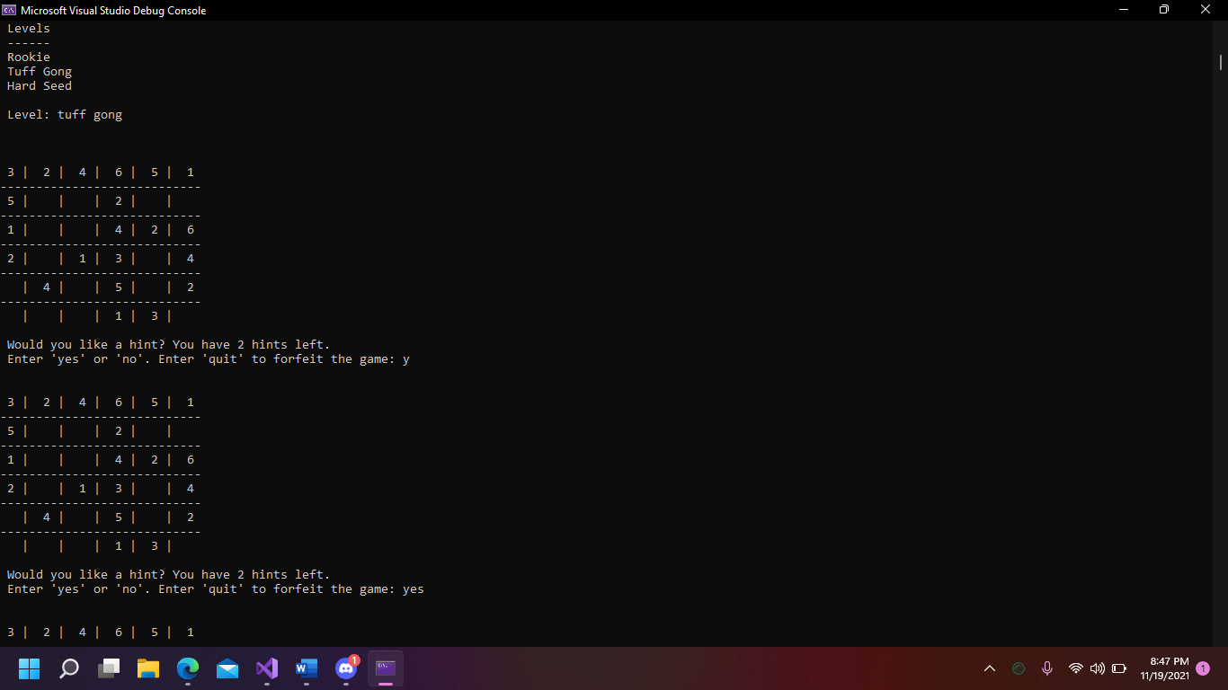

**Figure 21. Test Scenarios 18 - 20**

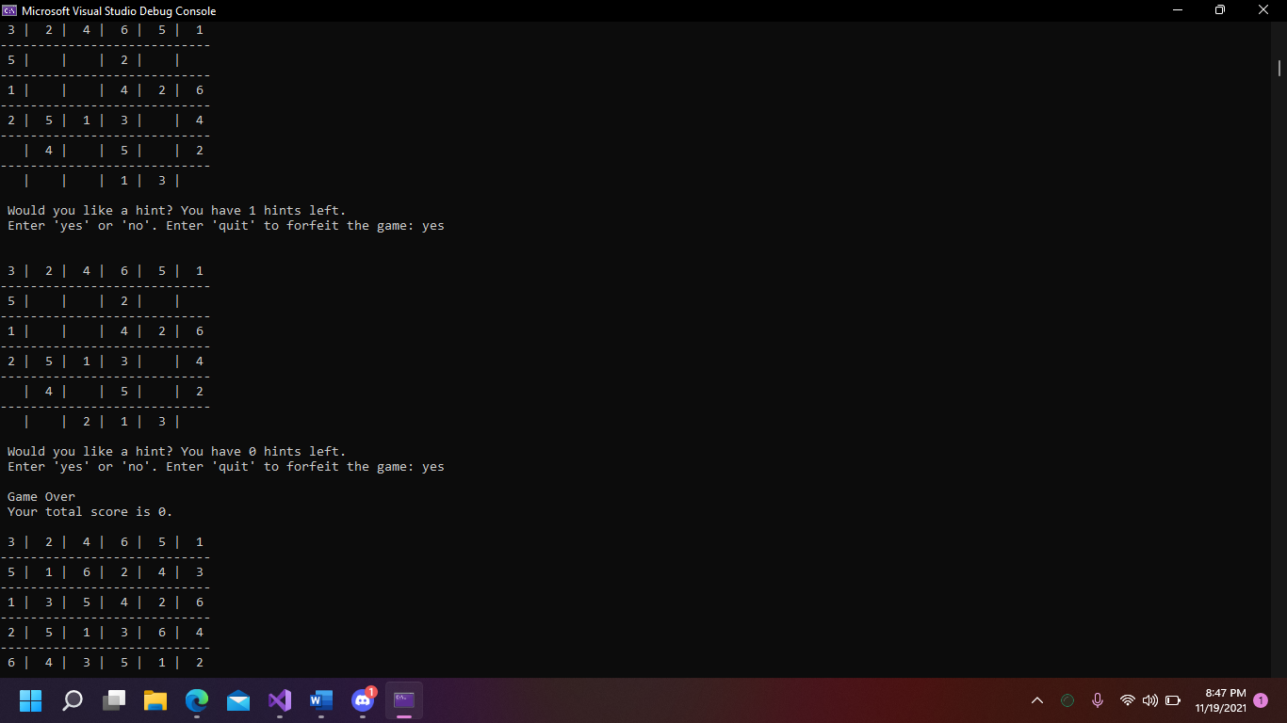

**Figure 22. Test Scenarios 21 - 22**

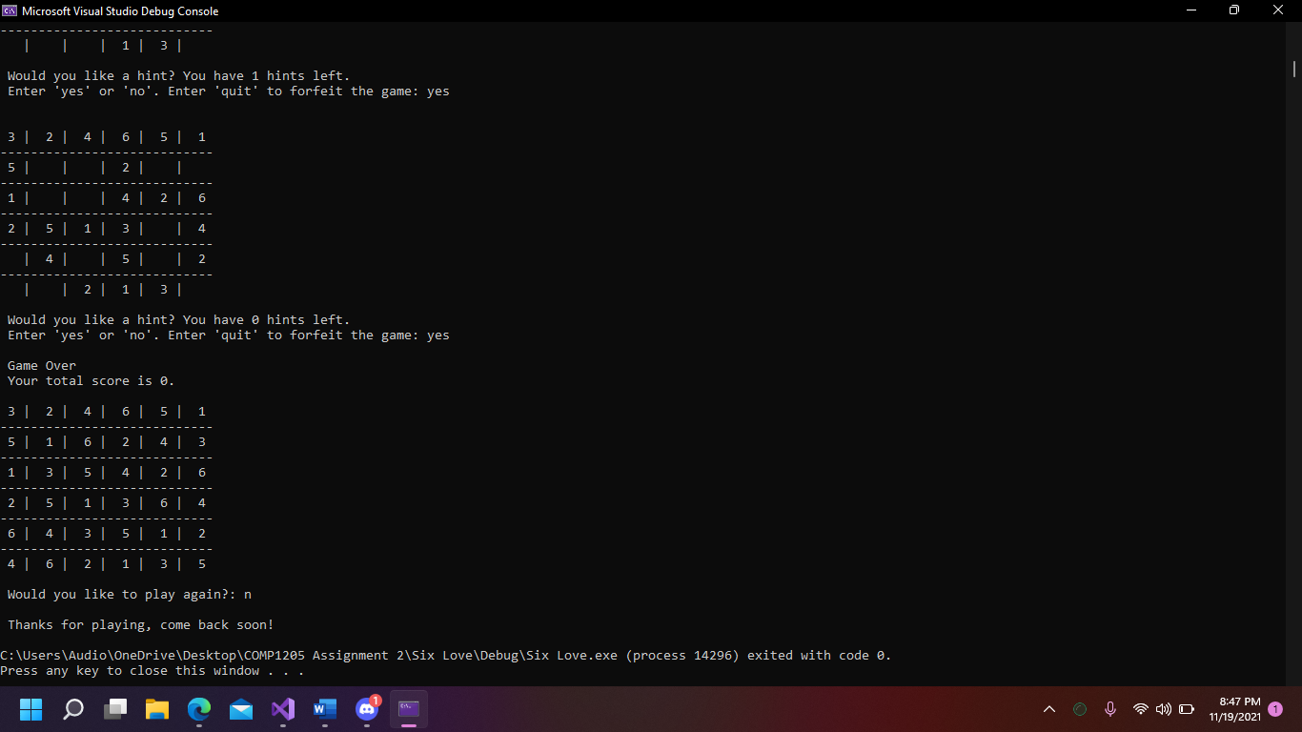

**Figure 23. Test Scenario 23**